2. Scenario: You are a data analyst working for a company that sells products online. You have
been tasked with analyzing the sales data for the past month. The data is stored in a NumPy array.
Question: How would you find the average price of all the products sold in the past month?
Assume 3x3 matrix with each row representing the sales for a different product..

Code;
import numpy as np
sales = np.array([
[100, 200, 300],
[150, 250, 350],
[200, 300, 400]
])
avg = np.mean(sales)

print("Average price of all products:", avg)

Input;
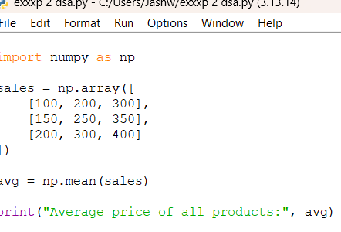

OutPut;
Average price of all products: 250.0

